Chapter 8, Solution 16.

At t = 0, i(0) = 0, v_{C}(0) = 40x30/50 = 24V

For t > 0, we have a source-free RLC circuit.

α = R/(2L) = (40 + 60)/5 = 20 and ω_{o} = 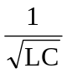 = 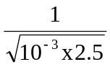 = 20

ω_{o} = α leads to critical damping

i(t) = [(A + Bt)e^{-20t}], i(0) = 0 = A

di/dt = {[Be^{-20t}] + [-20(Bt)e^{-20t}]},

but di(0)/dt = -(1/L)[Ri(0) + v_{C}(0)] = -(1/2.5)[0 + 24]

Hence, B = -9.6 or i(t) = [–9.6te^{–20t}] A

